# Group 16: Milestone 3

<https://students.bcitdev.com/A00850950/project/index.html>

Items completed in this milestone were:

* Index page
* About page
* Menu page
* Catering/signup/login page
* Art gallery page
* Contact page
* Site map

Issues our group had building the website included: building a fluid and responsive design, designing the base css for the navigation bar and footer before working on other pages, wrapper was not filling the entire page leaving large amounts of blank space on pages with less content

Withstanding issues:

No major changes from milestone 1 or 2.

# Group 16: Milestone 2

# The layout will be fluid, we will have a 2 column page layout, and the content will be divided among 2-3 columns depending on the page. The grey indicates an image, so text over a grey box would actually be text over an image. The navbar will be fixed in place to the leftmost margin, and the content to the right scrolls independently.

This is the home page. The logo on the navbar will, of course, be a link back to here.

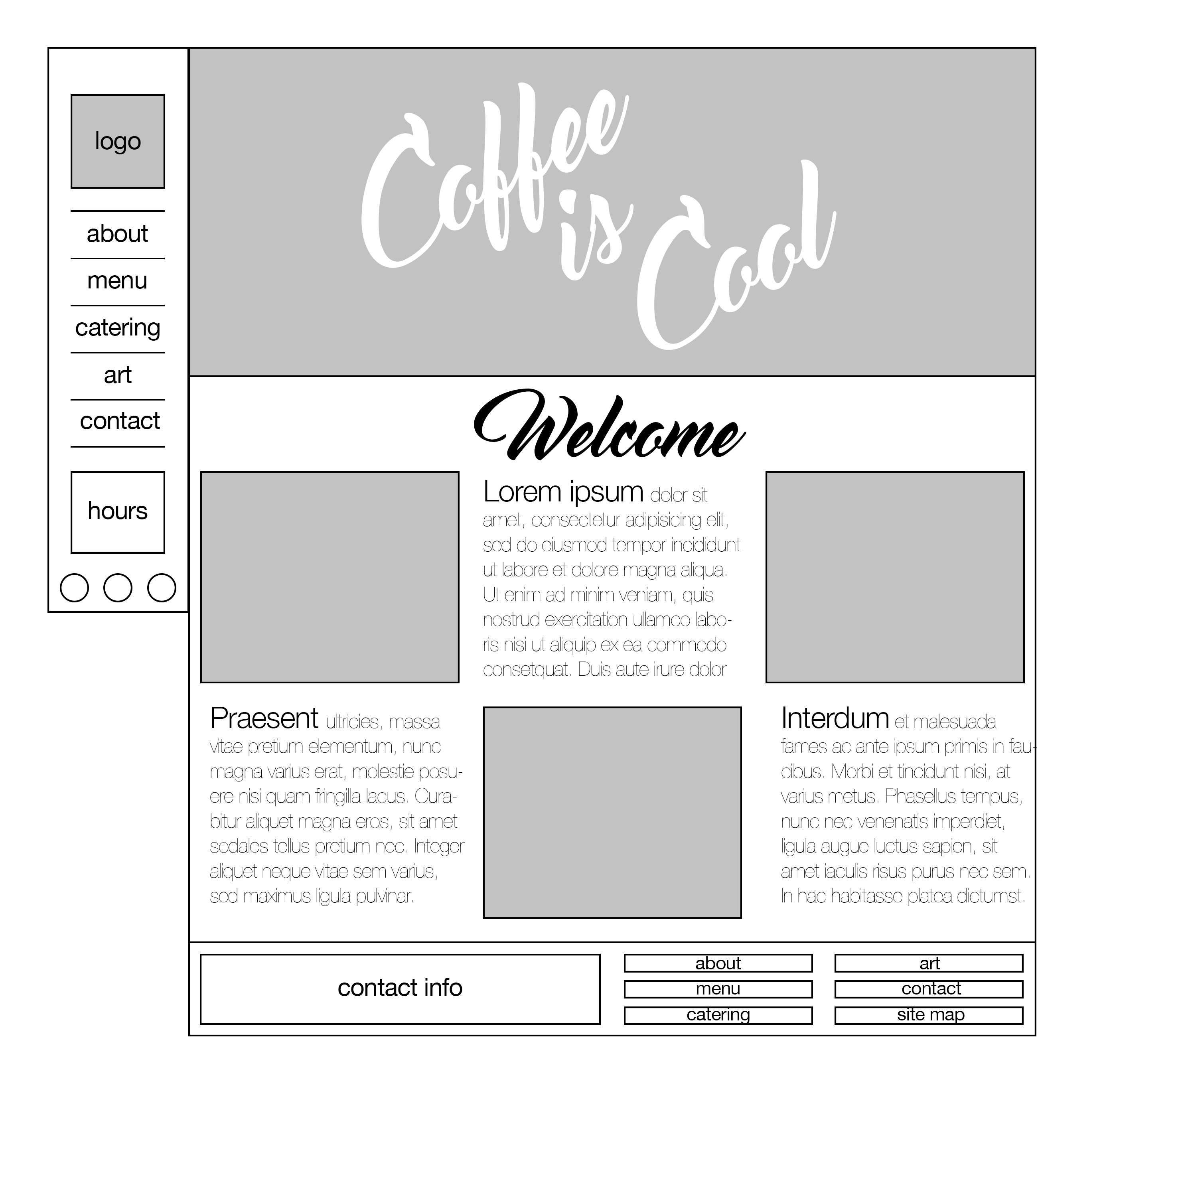

The about page. The demographic targeted by this coffee shop is one generally quite interested in helping the community and the environment, explaining why this coffee shop is superior to the competition in those areas is vital.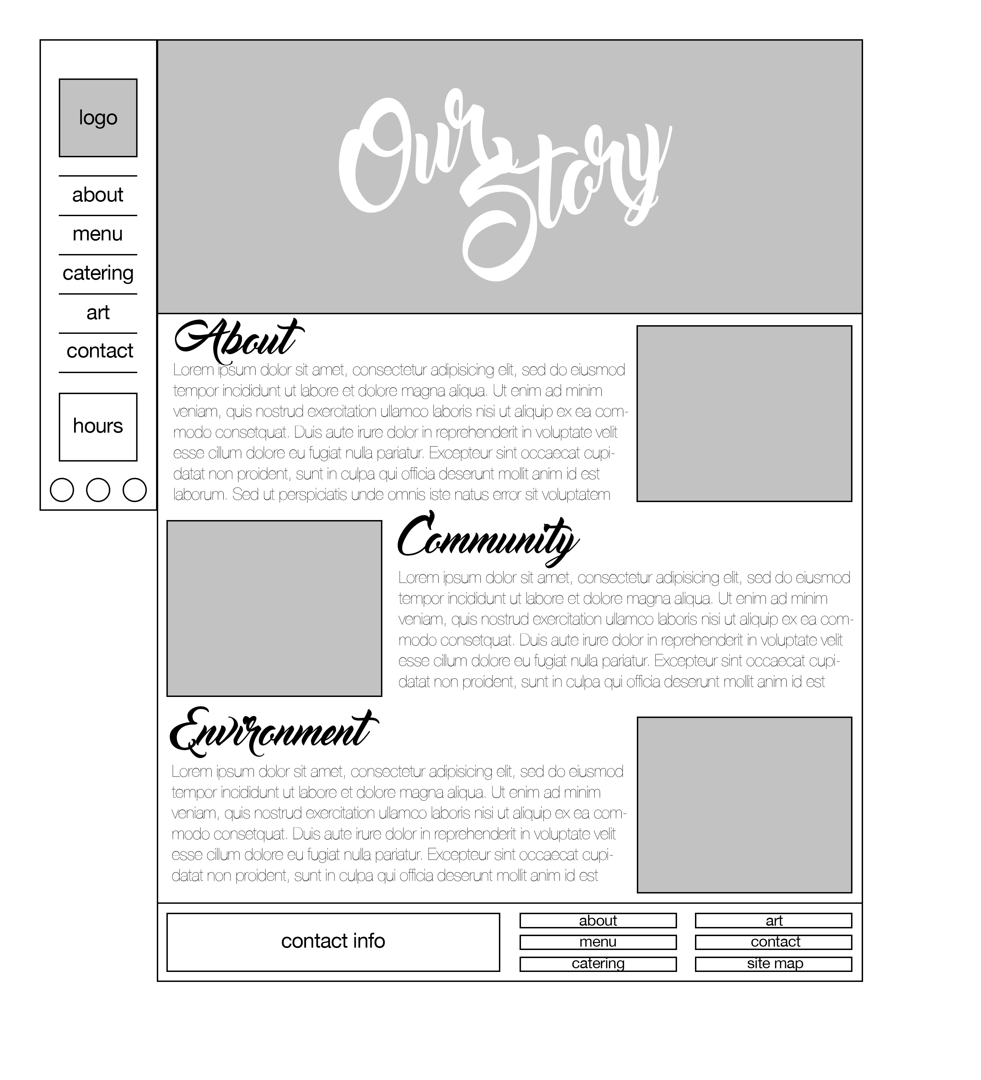

The menu will, as menus do, have a separate list of food and drinks (all paired with their prices). The right hand column will be adorned with photographs of delicious delicious products.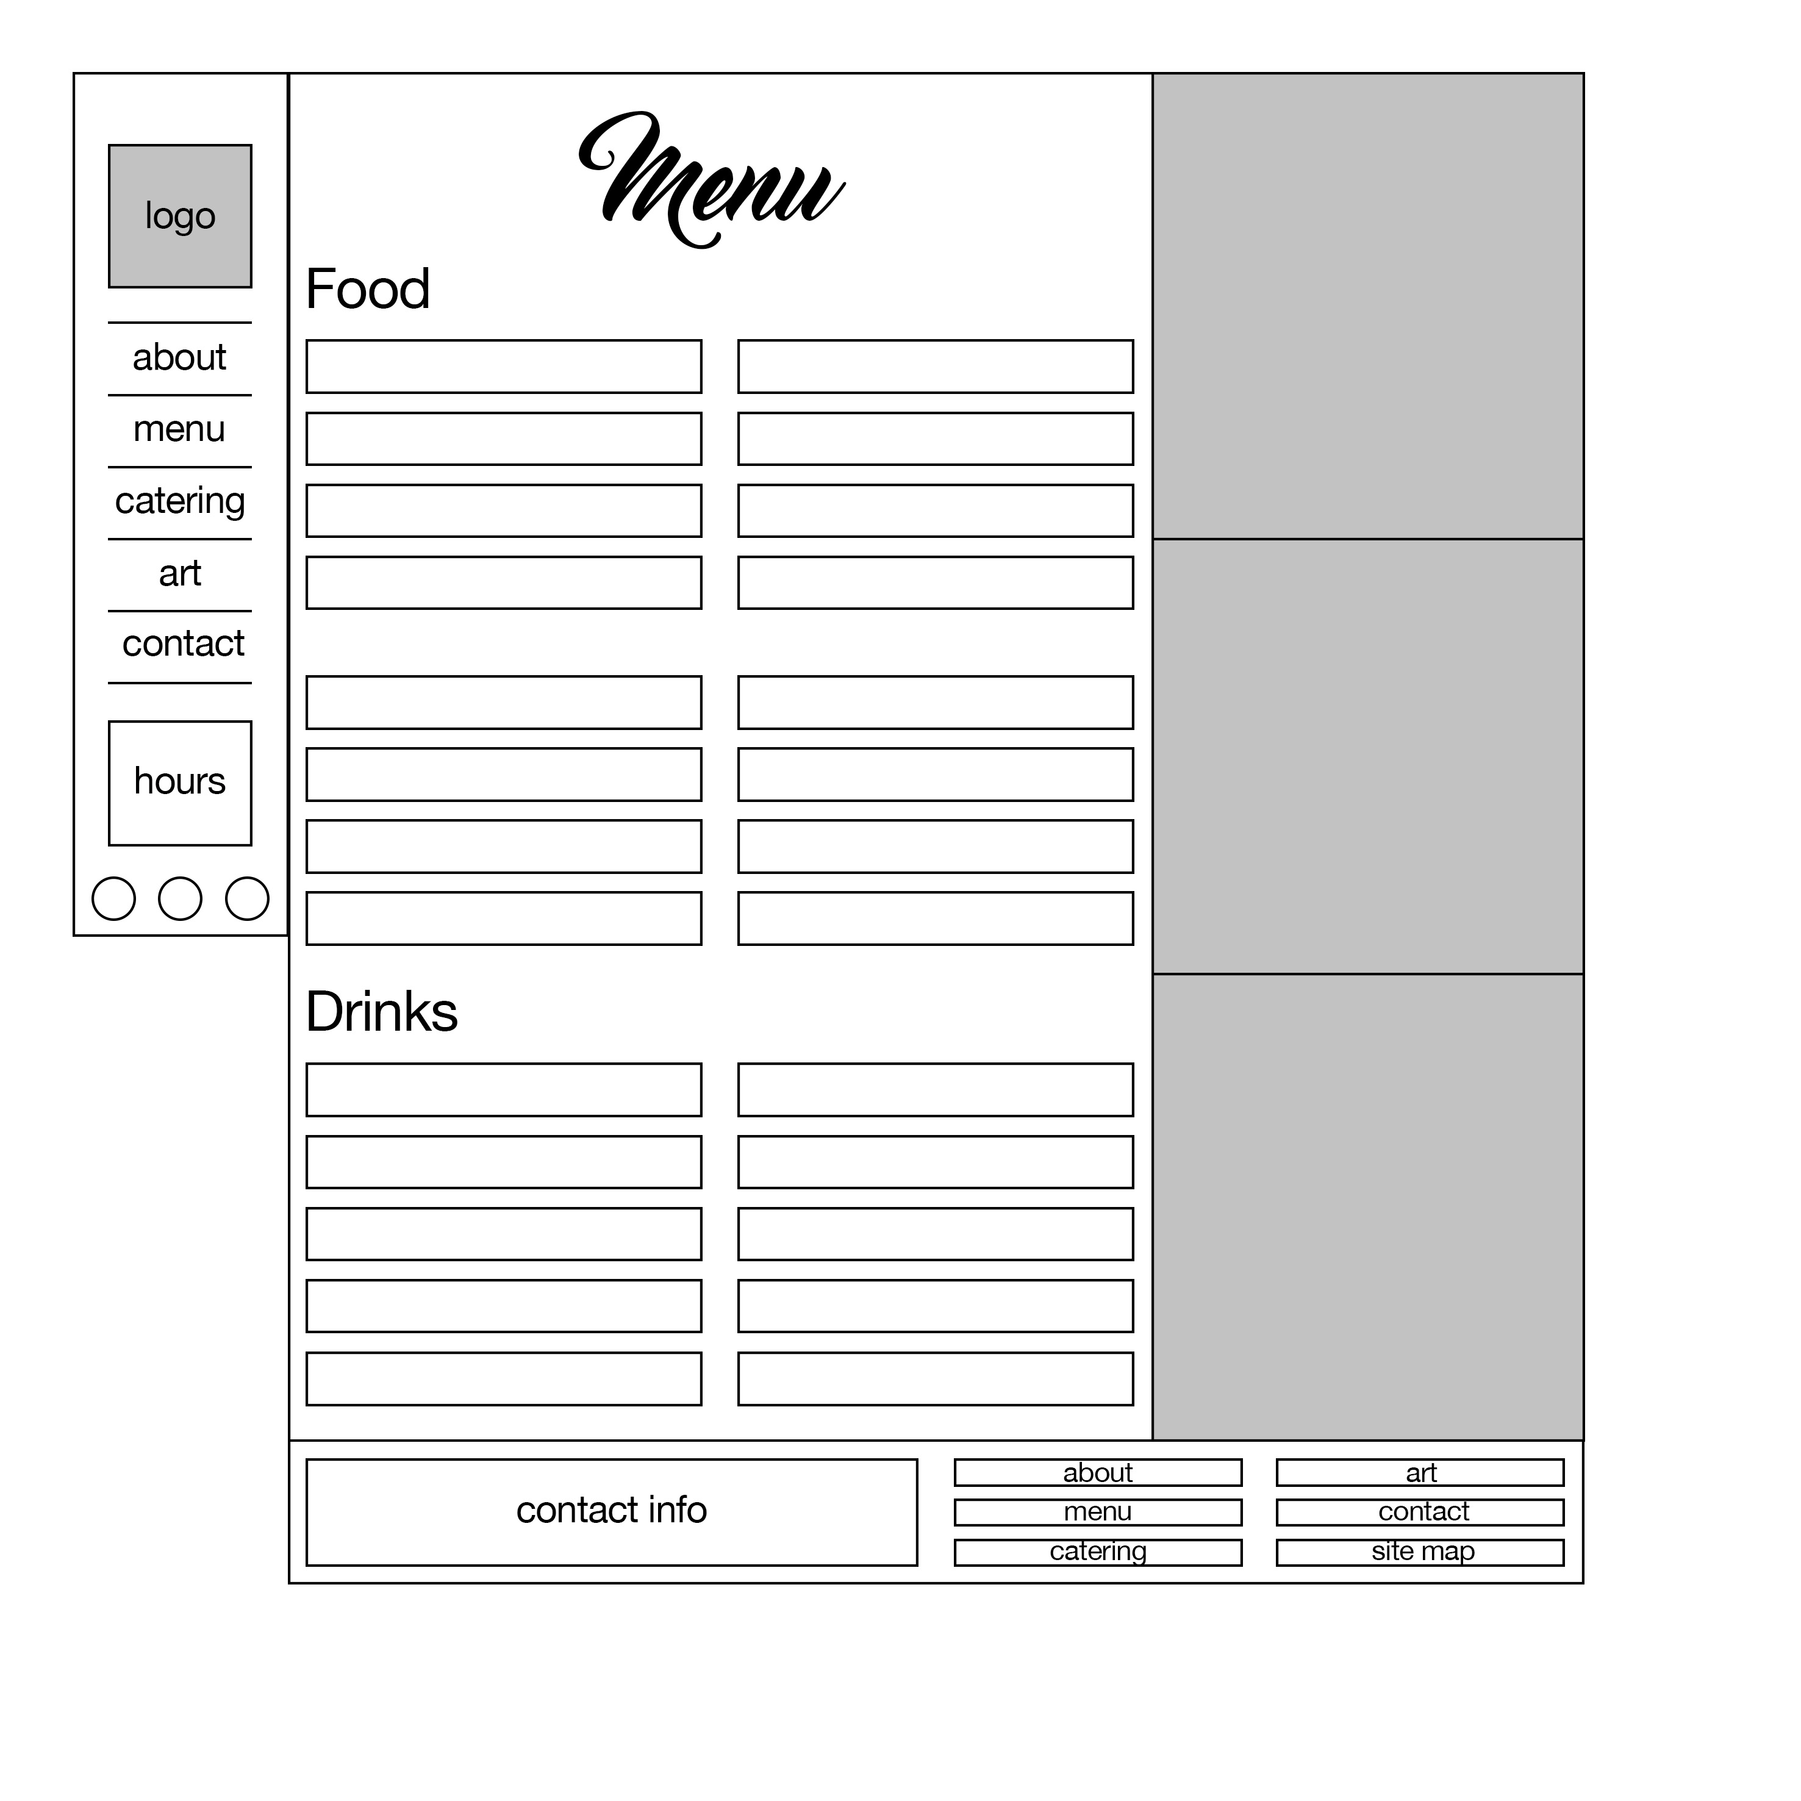

The catering section is another keystone page, seeing as this business offers a catering service. The sign-up/log-in fields will include information needed to perform deliveries, such as address and contact information.

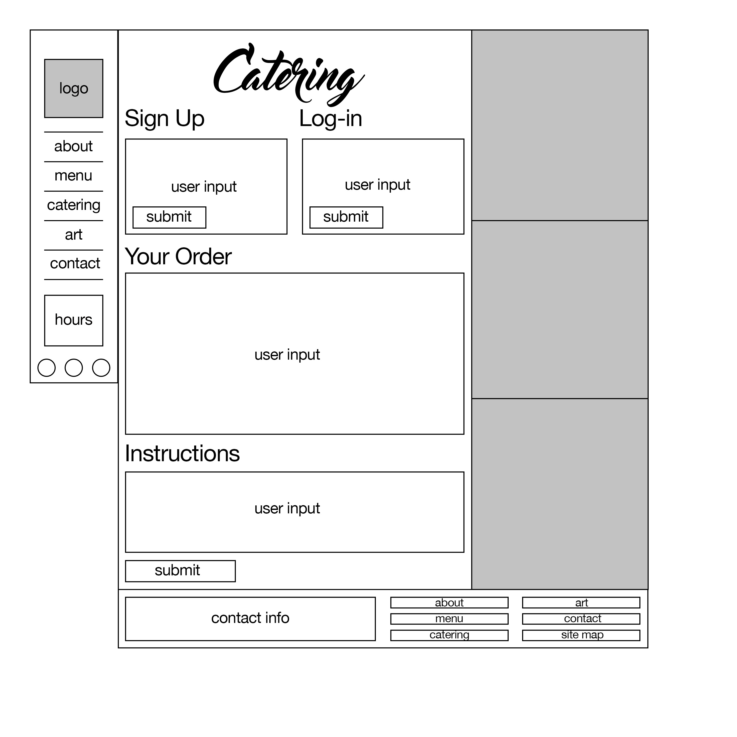

This business doubles as an art gallery that showcases and promotes one local artist at a time. As such, we thought it prudent to include a page with photos of some of the art being sold, as well as information about the artist currently showcased.

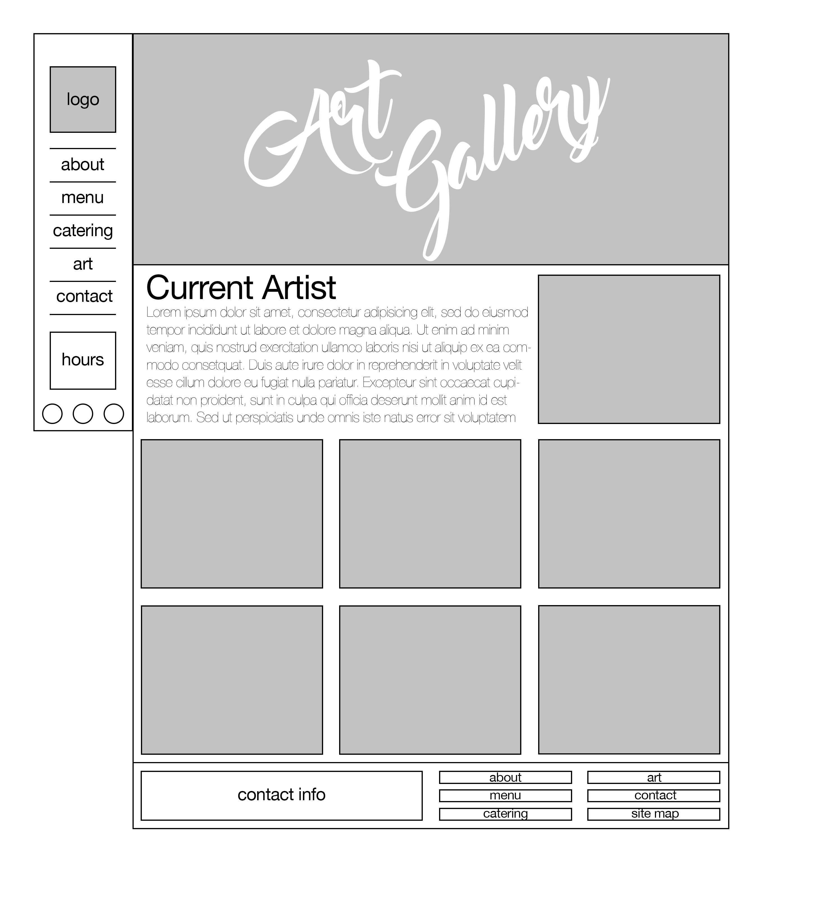

A contact page is, perhaps, the most important page for a restaurant to have. So important, indeed, that we included contact information and hours in the sidebar and footer of every page. This page is still useful, however, as it includes a map and a Q&A section.

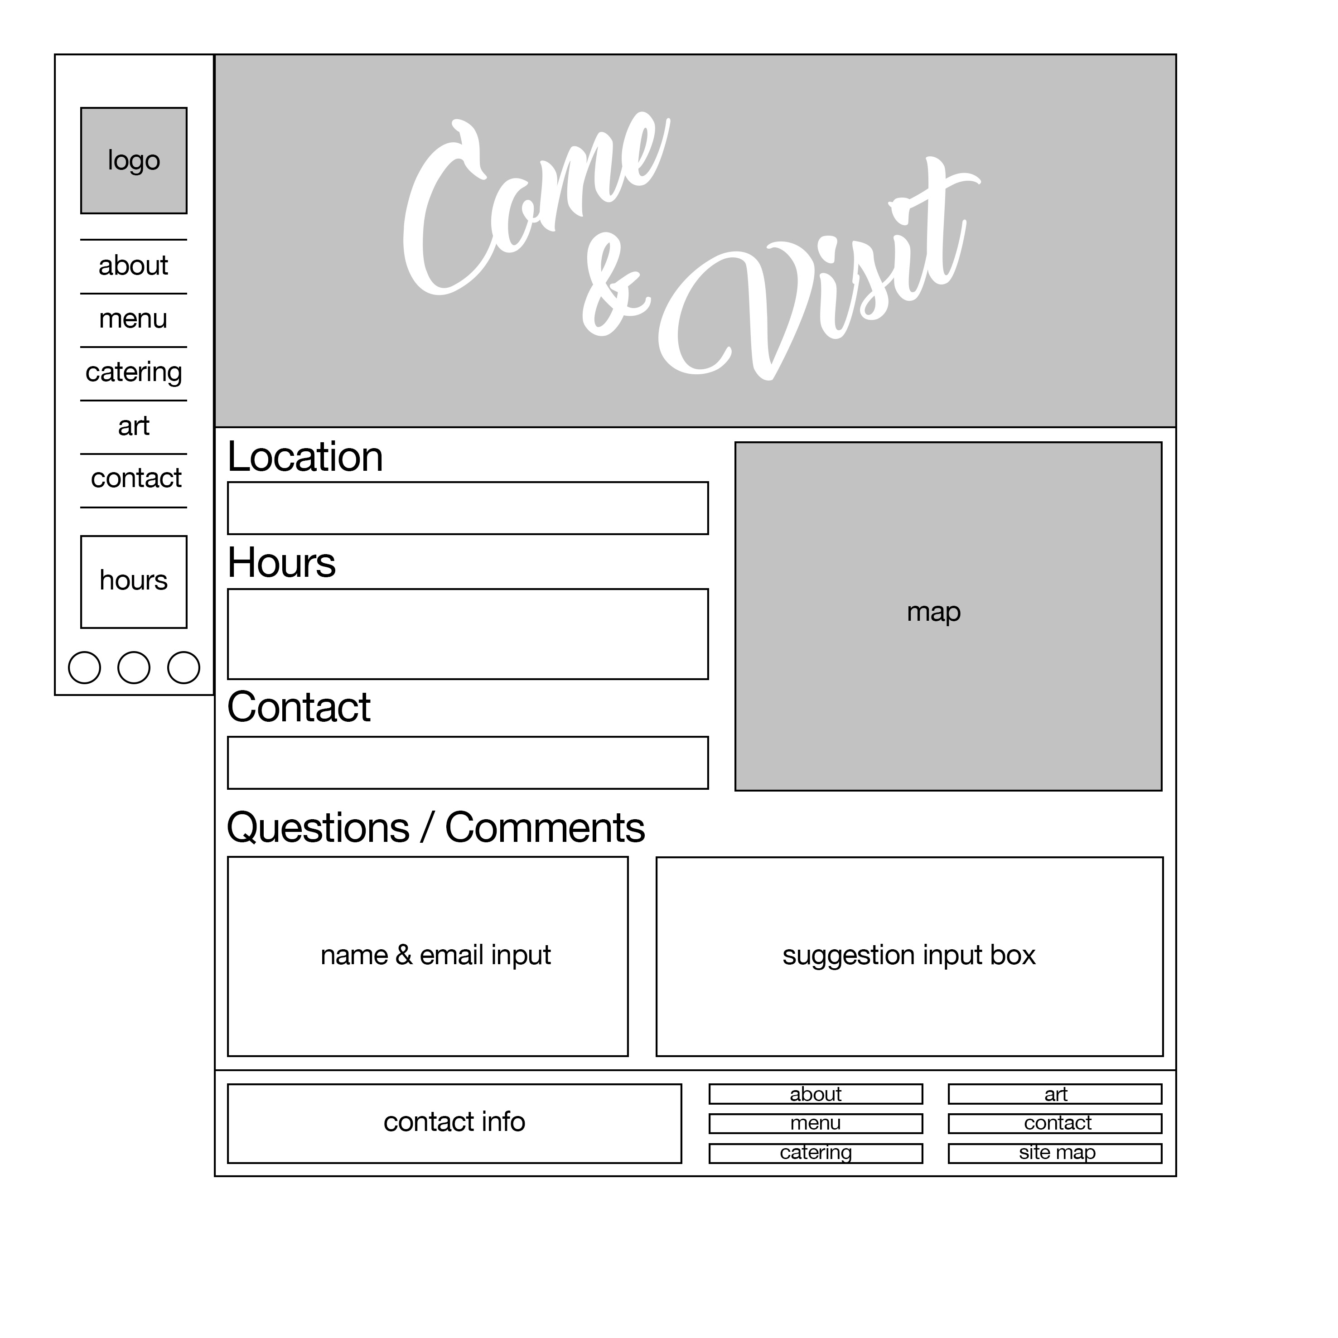

Coffee is brown. The logo is brown. We think it wise to keep our colour scheme thematically related to the subject matter. With that in mind, the following is the colour palette we intend to use. The text may be black rather than dark brown, but the background will be the lightest of the following, and the sidebar will be the top one.



From <http://paletton.com/palette.php?uid=10p0u0kllll7-txesprsehfEkd9>

Our sitemap is as follows

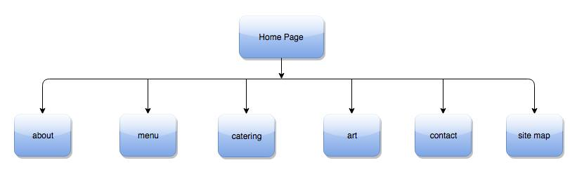

Accessibility is foremost in our design philosophy. The layout will be fluid to allow mobiles users easier access. The font will be fairly large to allow higher readability. The text will be very dark against the pale-brown background. Our website will be well within the 3 click rule, as every page can be accessed from our navbar.

# Group 16: Milestone 1

The Boulevard Coffee Roasting Co. is a boutique local grassroots coffee shop focused on a small batch bean-to-coffee approach. Located in the heart of the University of British Columbia, the café serves organic, fair trade coffee that is roasted on-site weekly.

## Purpose & Goals

The purpose of the website is to facilitate customer relations and to build on the existing customer base by enhancing accessibility to information and services as pertaining to The Boulevard Coffee Roasting Co. By increasing web presence, foot traffic into the café can be expanded, thus increasing revenue. The website must be clear and concise in conveying information but also appeal to the emotions of customers by telling a story, distinctly framing the coffee shop as a unique part of the community, a bustling hub of campus life.

## Target Audience & Demographic

Due to the café’s proximity to UBC, the primary demographic served is the community around the university, including the students, local residents, and people who work in and around the campus. These demographic groups are highly selective and want a clean and modern website that will reflect well on the business.

## Content

        The website design and content will align with the ethos of the business. With a focus on quality photo content that highlights the artisanal quality of the handcrafted drinks that the café creates, the site will be an appeal to the discerning nature of customers who want quality service at the pace of university life. The text of the site will be clear and concise, functionally providing easy access to the menu, catering form, contact information, location, hours, and other business specifics. The ethical nature of the business, with its focus on organic and fair trade coffees, will also be emphasized and interwoven into the narrative of the website.

## Success Factors

        The website must be easy to navigate, widely accessible, provide pertinent information up front, and have a coherent appearance and style. This will increase business revenue, and enhance communication between the café and its customers. The website will extrapolate on the brand identity of The Boulevard Coffee Roasting Co., positioning the café as an integral part of the campus lifestyle, thus furthering the business’s reach into the mindshare of potential patrons.

## Critique

        theboulevard.ca – The existing website for the business is outdated with an unnecessary landing page that wastes bandwidth and serves no functional purpose. Once into the main website, the logo at the top is a link back to the landing page. The menu page that lists food items is crowded, attempting to serve up too much information at once, with no delineation and spacing to guide the viewer’s eye around. The café provides a catering service that is not advertised on the website at all. The use of light coloured text offers bad contrast and hinders accessibility. There are also no photos of the actual café itself nor any photos of drinks and food from the café. This is an oversight, as there is nothing to actually entice the customer into the café.

badasscoffeestore.com - This website, while somewhat aesthetically pleasing, does not adequately serve its purpose of selling coffee because of its extremely slow loading times, especially on the products page where the long loading time hinders the customer’s ability to browse products. The store locator contains a list of stores that has a bright white background that is not coherent with the tan colour scheme of the rest of the website. The about us page simply contains two links to further information about the business, this could have been condensed into a dropdown menu that leads to the two pages, or even consolidated with the main page. Also, on the product page, the website uses a skeuomorphic wood grain that does not conform with contemporary design standards that skew more in favour of embracing honestly digital designs. The faux wood pattern will not age well and simply looks cheap.

## Functional requirements

User submitted form: The café provides a catering service for events and meetings. Currently, catering is ordered strictly by phone or in person; this is an unnecessary and convoluted process that wastes employee time. The website will have a page from which those seeking catering will be able to submit their orders online, streamlining the process.

Table list: In order to clearly display items available for a catering order, a list will be used to convey the menu.

## Work Plan

Sheldon will be responsible for the overall artistic vision of development (photographic content, colour schemes, typesetting, etc.)

Layout/HTML/CSS of the website will be a shared group effort. Once a wireframe and sitemap has been established, the index page will be worked on by the entire group. This will become the basis off of which every other individual page will be modeled. Each group member will be responsible for a different page, customizing content and layout so that the individual purpose of each page is served.

The group will meet at least twice a week to work towards each project milestone. Additionally, individual members will have tasks that can be completed at home, to be brought back to group meetings where individual efforts can be combined into the main project. All of this will ensure timeliness and compliance with deadlines.